Duke Medicine



CoreResearch@Duke
External User
Navigation & Notifications User Guide
08/08/18
Version 2.0

Table of Contents
Target Audience 3
Facility User Job Type Access 3
System Requirements 3
Login Process 3
Navigation 4
General 4
Sitemap 4
Page Tabs 4
Toolbar 5

Target Audience
This document was written to support the activities for the following CoreResearch@Duke Job Types: Facility User, PI, PI Delegate and External Facility User. Throughout the remainder of this document, these Job Types will be referred to as “External Users.”

Facility User Job Type Access
Facility User accounts are created automatically when a person from the Duke system is linked to a PI by the PI, PI Delegate, or Financial Manager. After a facility user account is created through the PI linking process, the facility user must then be added to the fund code as a member of the project to use the code.

System Requirements
Supported Browsers:
- Internet Explorer
- Chrome
- Safari
- Firefox is NOT supported.
- Edge is NOT supported.
Pop Up Blockers MUST be disabled for this site.

Login Process

To access the CoreResearch@Duke application, users must go to http://coreresearch.duke.edu. Users will be presented with a login screen. The login process validates the Duke NetID and password provided and logs the user into the CoreResearch@Duke application if the user has an active account.

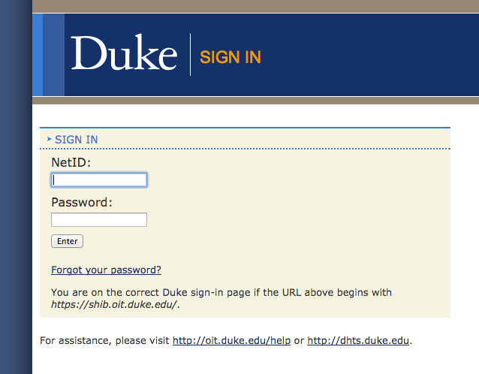

The login process determines what job types the logged in user can have in the system. Job types are assigned to the user when an account is established. A user’s Job Type determines the pages and operations available to the user.

At any given time, the user can be logged into the system with only one job type, though the user may have many job types assigned to them. Switching to another job type can be done in the job type dropdown at the bottom of the page. If a user only has one job type assigned, they will not see this as a dropdown and instead it will show the single job type as static text.

Navigation

General
Do not use the ‘Back’ or ‘Forward’ buttons in your browser. Only navigate within the confines of the application. Selecting ‘Back’ in your browser will force you to refresh the page and may clear any pending operations.

Sitemap
On login, a Sitemap is presented specific to the currently selected job type of the user.

By default, External Users have access to the External Sitemap. The sitemap and logged in job type defines which functions and operations are available to you. Tram Lines and Tram Stops organize the available functions.

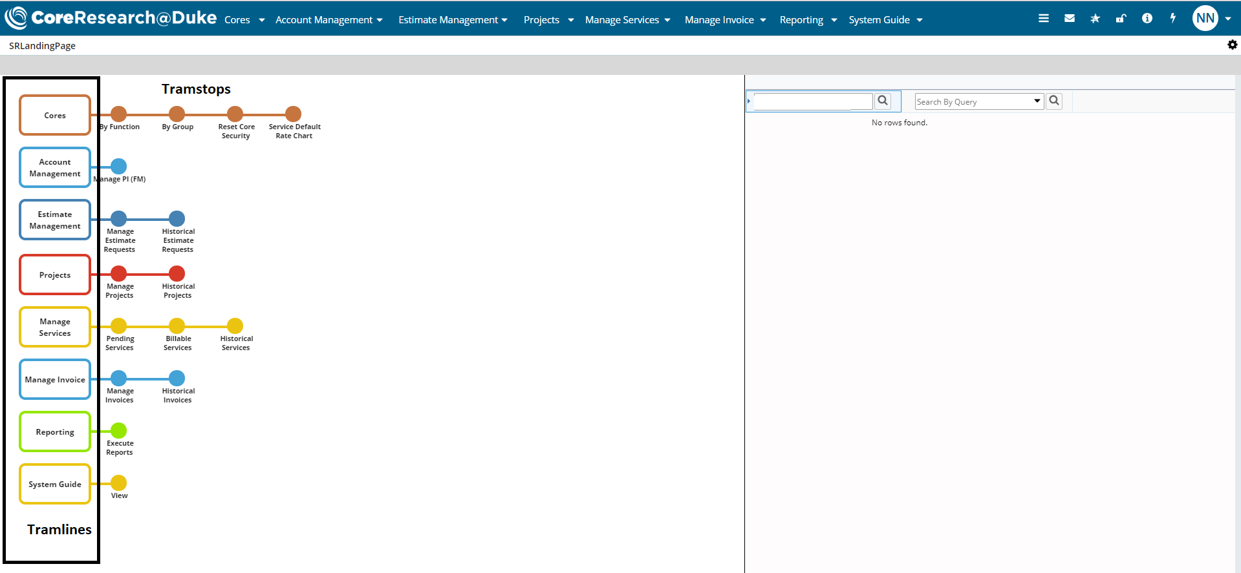

Page Tabs
Within a Tram Stop, there are a number of navigation options to select desired content.
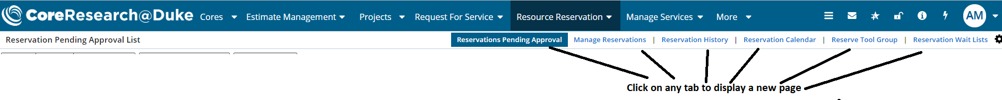

Toolbar
At the top-right of the application, there is a Toolbar with several operations:
Toolbar 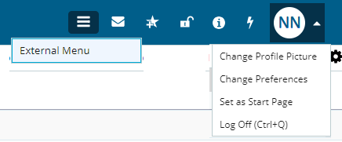
 | Add to Favorites – Add the current page to the list of favorite pages on the main sitemap.
 | External – Navigate to the main External sitemap
 | Change Preferences – Allows you to view your user information as well as set Email Notification Inclusions.
 | Clear My Previous Sessions – Logs off previous sessions. In case you are logged into the application from multiple browser windows/tabs or multiple computers, this clears all previous sessions.
 | Log Off – Log off the CoreResearch@Duke application. Recommended every time you are done using the application.

Notifications (E-mails from CoreResearch@Duke)
You can specify which e-mails you would like to receive from CoreResearch@Duke through the User Preferences.
To update your notification preferences,
1. Select your initials form the upper right corner and click Change Preferences
2. Click the Notification Inclusions detail tab
3. Click Add New
4. Select the checkbox next to the notifications that you want to receive.
5. Click Select & Return
6. Click Save
