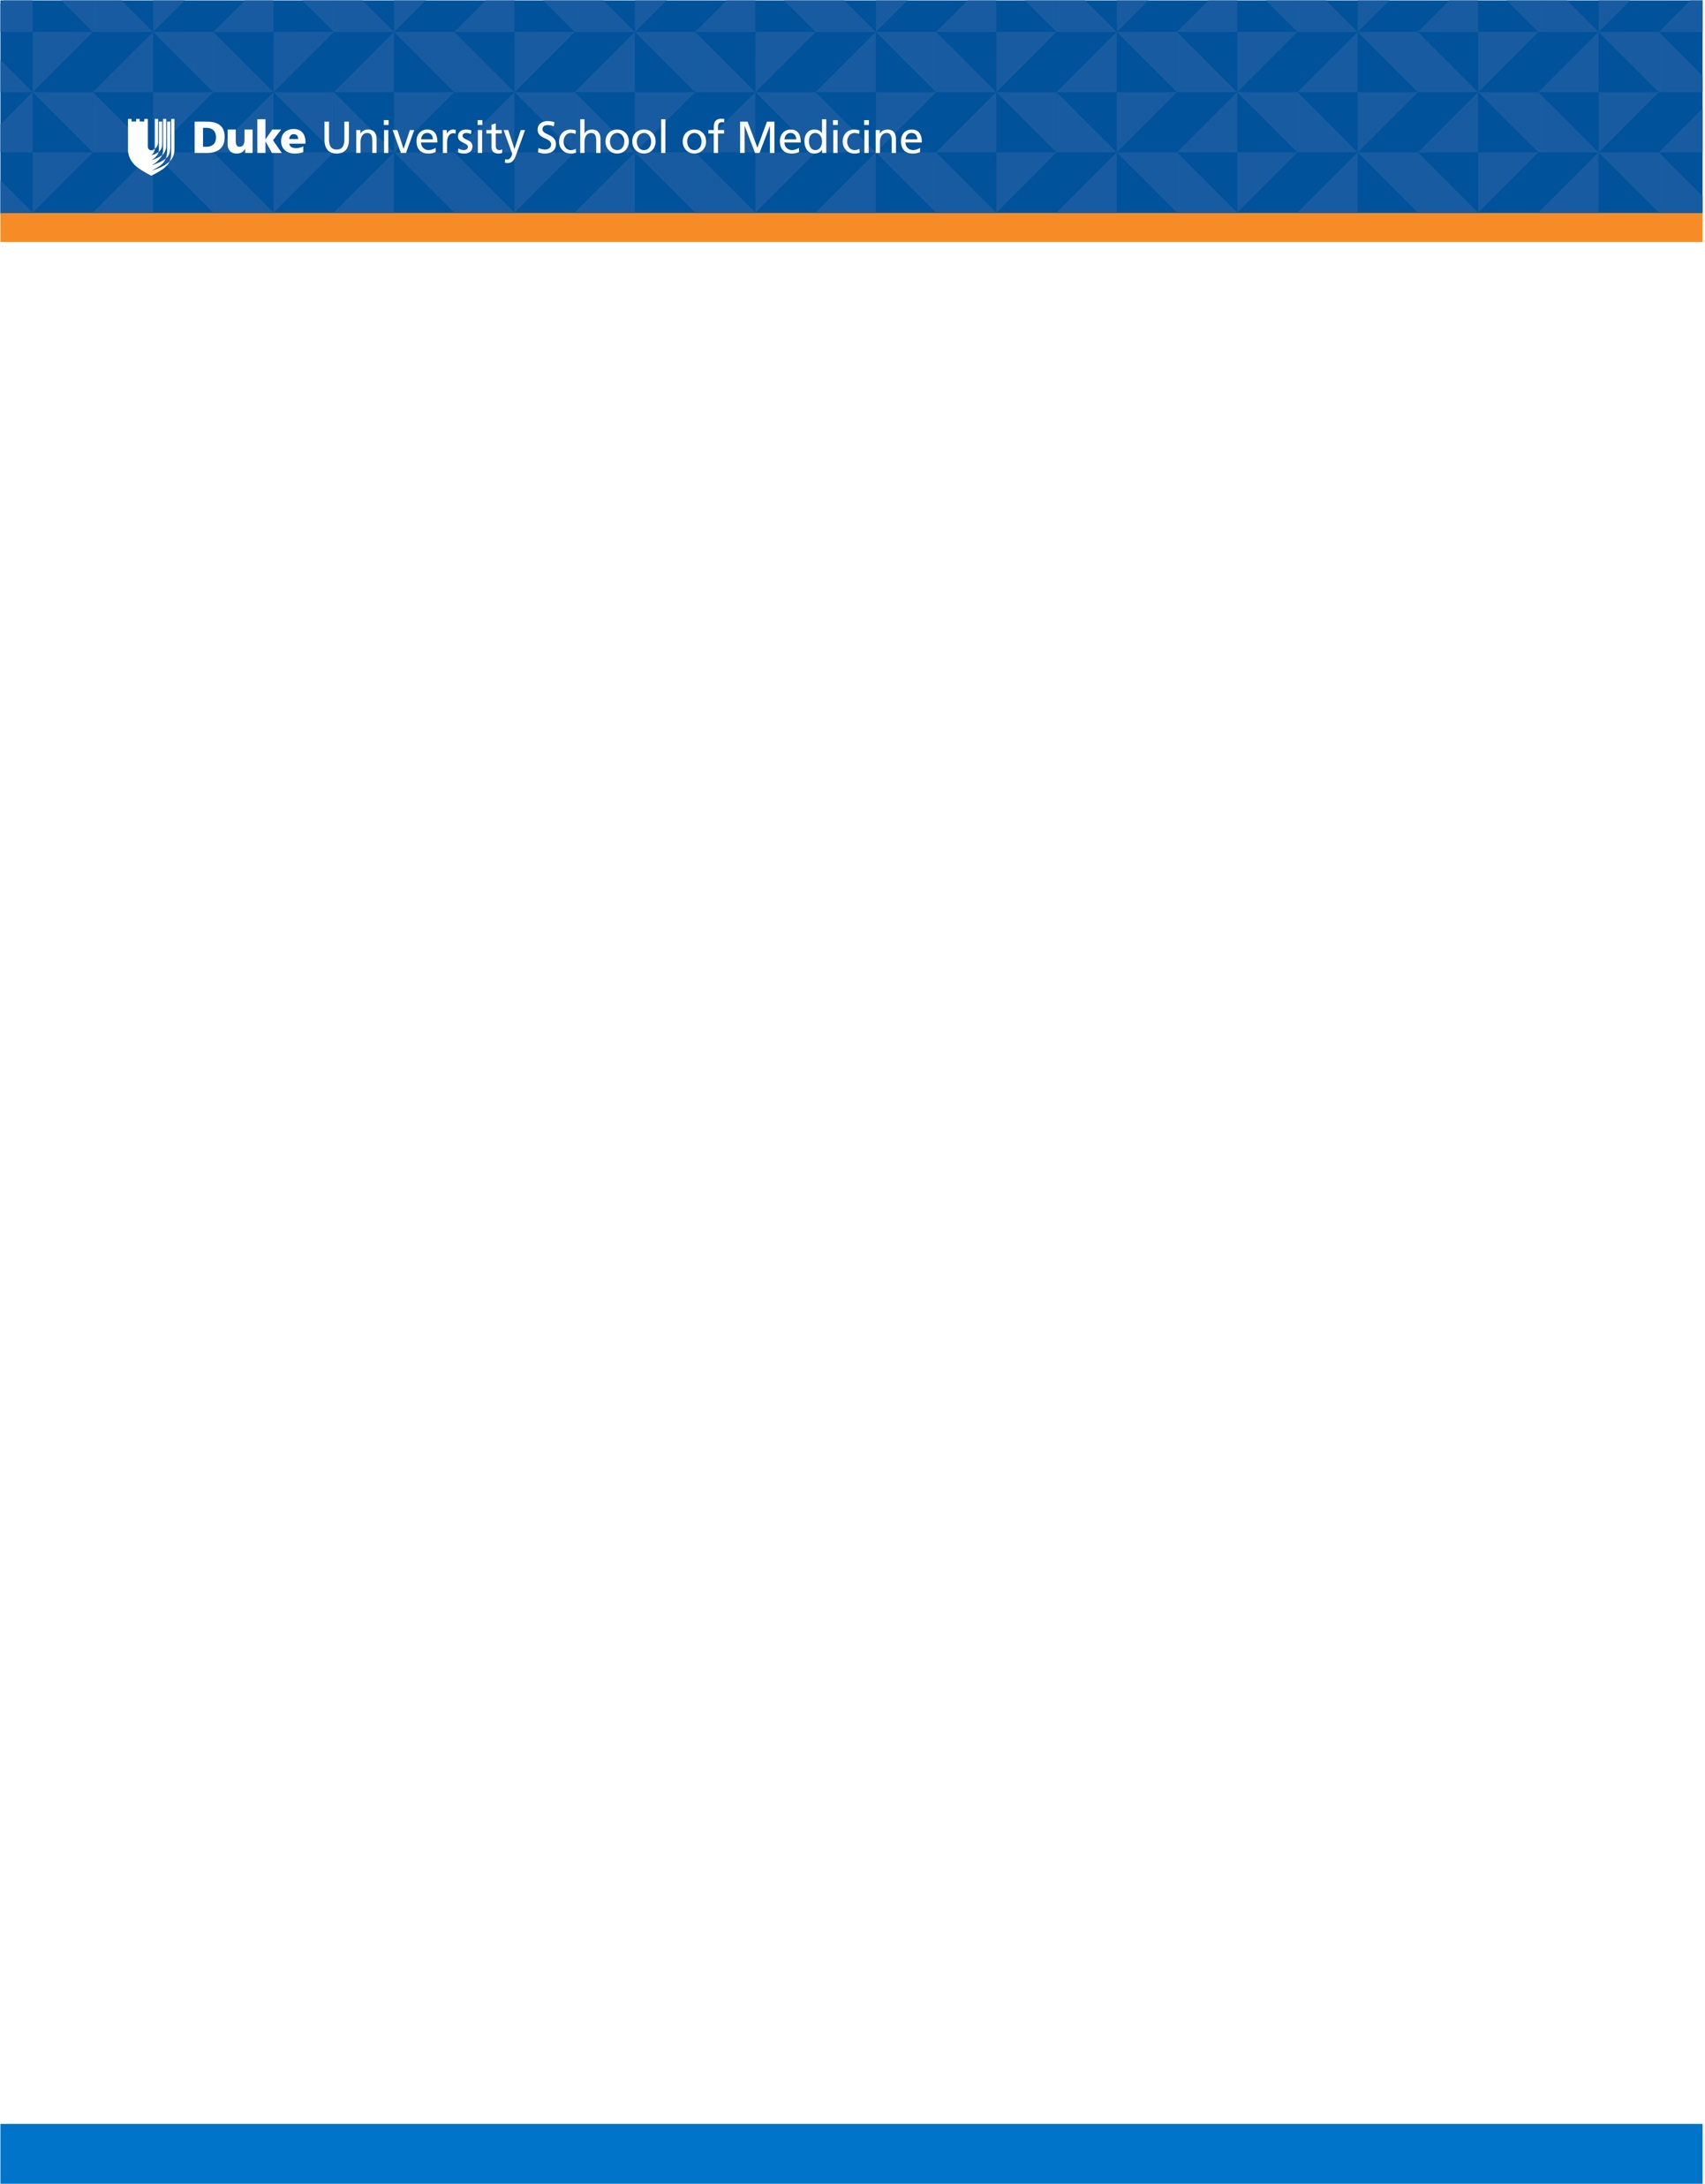
Headers Open Sans light, 24 pt., PMS 287 blue (r0, g83, b155)
Headers Open Sans semi-bold
Headers Open Sans bold

Sub-Titles Open Sans bold
Sub-Titles Open Sans bold, PMS 715 orange (r0, g83, b155)

Text Open Sans regular 12 pt. black
Text Open Sans regular 10 pt. black

Text Open Sans regular 12 pt. grey (80% black)
Text Open Sans regular 10 pt. grey

